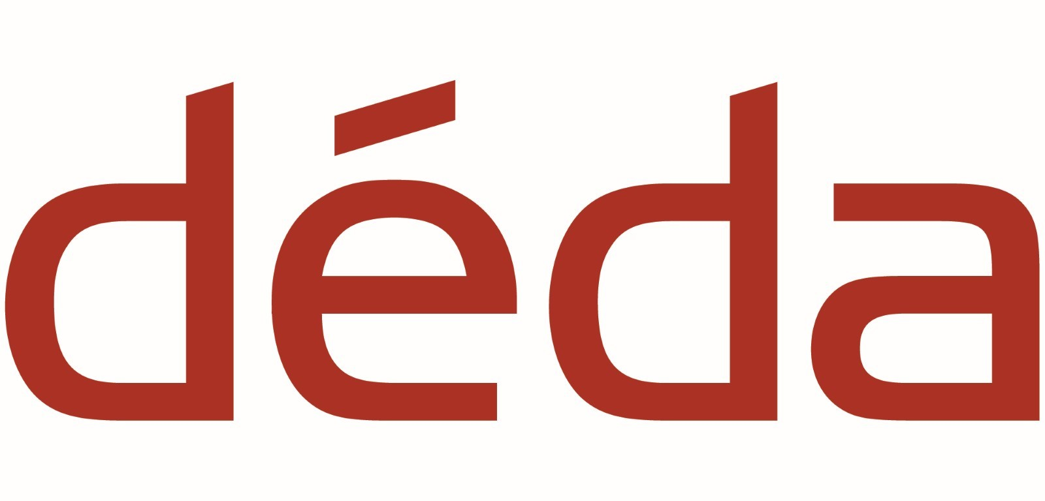

Déda Chairperson vacancy
Déda is an ambitious, entrepreneurial, and well-established cultural venue in Derby offering a range of dance, movement, festival, leisure and educational activities and experiences.
We are looking for a new Chairperson to join our Board as we embark on building and strengthening Déda’s new vision and business strategy. An essential element of our plan is to support the Arts Council England’s Let's Create strategy by focussing on the four investment principles of: Ambition & Quality; Dynamism; Environmental Responsibility; and Inclusivity & Relevance.
Building on Déda’s strengths of artistic, educational, financial excellence and bold accessible outdoor activity, Déda is seeking individuals that are willing and able to invest their knowledge and creative energy into shaping our new vision as an innovative, diverse, and outward facing cultural organisation that enriches the lives of our communities.
Déda is looking beyond its creative horizons to successful dance/arts institutional models from around Europe, such as CAMPO in Ghent and BLACK BOX Teater, Oslo. In this way, our ambition is to create hyper-local yet international facing work of relevance and place - ensuring Déda is a vital cultural resource for Derby, the Midlands, the UK and beyond.
Déda works closely with the people and communities which fall within a 15-minute walk or cycle of the building, to spotlight us as a communally accessible space for everyone.
We are interested in applicants that can connect with our ethos and community and that have a background or specialism in the following:
- Creative movement, performance, dance
- Entrepreneurialism and business strategy
- Accessibility and inclusion
- Leisure and tourism
- Marketing, Public Relations and media
- Academia and education
We warmly encourage applications from anyone that feel they can make a difference, particularly those who can bring a new perspective, for example people:
- Who are local to us (within 15 minutes' walk or cycle of Déda) or are invested in the local communities of Derby; or
- Aged 18 – 30; or
- From a range of ethnic and cultural backgrounds; or
- With physical or learning disabilities or who are neurodivergent; or
- From a range of socio-economic backgrounds, particularly from low-income families; or
- With an interest in families and creativity.
Ideally you will have previous experience as a Trustee or a board member.

General duties and expectations
The Board of Trustees ensures Déda has a strong governance structure and compliance with our governing organisations, the Charity Commission and Companies House. Training and induction to your duties and responsibilities will be provided so that you are well prepared. Being a Chairperson is a volunteer role that will provide, in return for your commitment, a wealth of experience and transferable skills.
You will be expected to:
- Attend quarterly board meetings either in person or online when necessary.
- Attend one or two annual strategic planning days.
- Attend events regularly at Déda, including special VIP events and other regular activities, to promote better understanding of the core offer of the organisation.
- Act as ambassadors for the organisation, both internally at Déda and in everyday life.
- Support fundraising and development campaigns by introducing friends and colleagues to the organisation, liking and sharing our social media releases and attending seminars or training where necessary.
The term of a Trustee is currently unspecified in our governing documents though this will be reviewed in 2022.

Chairperson role - specification
The Chairperson has all the same duties as a Trustee with additional requirement to:
- Support Déda’s vision and strategy
- Have a supportive, robust and critical relationship with the CEO
- Be well-connected in their field of expertise and prepared to use those contacts to advocate for Déda; to increase Déda’s profile and reputation
- Be connected locally and/or nationally. (It is not essential to be based in Derby, but you need to have a connection to the city and be able to attend events)
- Chair meetings, manage the Board and the relationships between Trustees and staff
- Lead on due diligence
The Chairperson will also need to steer the development of new models and drive thinking, and growth in one or more of these four areas:
- Dance
- Outdoor, site specific / street arts & festivals
- Inclusion and diversity
- Creative sector education

How to apply
If you are interested in applying, please send us a brief expression of interest stating why you are interested in becoming a Déda Chairperson and what skills you think you would bring to the role.
- You can do this by sending an email or by creating a video link to the Company Secretary by 2 May 2022
- Please complete the Déda applications monitoring form here: https://www.surveymonkey.co.uk/r/dedaboard
If you would like to discuss this opportunity first, please email our Director, Steve Slater to arrange an informal chat.
Deadline: 2 May 2022.

More about Déda
Déda is a Creative Centre for Dance, Movement and Creativity based in the heart of the cathedral quarter in Derby that has three dance and one aerial studio, a 124-seat theatre, environmentally friendly café bar, gallery, and creative spaces. Déda produces Derby Festé - an annual international outdoor street-arts festival attracting iro 30,000 people to the city each year, and created and produces Altered Streets, a new initiative that brings a festival feel with art, culture, and engagement outdoors with a focus on Chapel Street (where we live).
Déda runs an ambitious creative engagement programme that includes an academy for children and young people to dance and move, BA (hons) and MA programmes, artists residencies, outreach programmes, family friendly entertainment, music and dance nights, theatre experiences and much more.
We are a band 2 Arts Council England National Portfolio Organisation, a registered charity (1053633) and a Company Limited by Guarantee (03100413).
We attract 54,000 visitors to our building each year.
For more information visit www.deda.uk.com and www.derbyfeste.com

Déda Purpose
To deliver the benefits of dance & movement to every body.

Déda Vision
To enrich people’s lives through dance, movement and creativity, producing hyper-local yet international facing work of relevance and place.

Déda Mission
Through diverse imaginative dance, movement and creative engagement practice; we will work to inspire artists, participants and audiences of all ages, cultures and means, to make art that moves.

